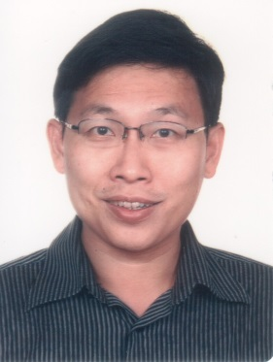
Woon-Seng Gan, Nanyang Technological University, Singapore
Biography:
Woon-Seng Gan received his BEng (1st Class Hons) and PhD degrees, both in Electrical and Electronic Engineering from the University of Strathclyde, UK in 1989 and 1993 respectively. He is currently an Associate Professor and the Head of Information Engineering Division, School of Electrical and Electronic Engineering in Nanyang Technological University. His research interests span a wide and related areas of adaptive signal processing, active noise control, directional sound system, psycho-acoustical signal processing, and real-time embedded systems.
Dr. Gan has published more than 200 international refereed journals and conferences, and has granted five Singapore/US patents. He had co-authored a book on Digital Signal Processors: Architectures, Implementations, and Applications (Prentice Hall, 2005). He was also the leading author of a new book on Embedded Signal Processing with the Micro Signal Architecture, (Wiley-IEEE, 2007). A book on Subband Adaptive Filtering: Theory and Implementation was also published by John Wiley in August 2009. He had also authored a book chapter in Rick Lyon's latest book on Streamlining Digital Signal Processing: A Trick of the Trade Guidebook, 2nd Edition, published by Wiley-IEEE press, 2012.
He is currently a Fellow of the Audio Engineering Society(AES), a Fellow of the Institute of Engineering and Technology(IET), a Senior Member of the IEEE, and a Professional Engineer of Singapore. In 2012, he became the Series Editor of the new SpringerBriefs in Signal Processing. He is also an Associate Technical Editor of the Journal of Audio Engineering Society (JAES); Associate Editor of the IEEE Transaction on Audio, Speech, and Language Processing (ASLP); Editorial member of the Asia Pacific Signal and Information Processing Association (APSIPA) Transactions on Signal and Information Processing; and Associate Editor of the EURASIP Journal on Audio, Speech and Music Processing. He is currently a technical committee member of the Design and Implementation of Signal Processing Systems (DiSPS), and the Industry DSP Technology (IDSP) standing committee of the IEEE Signal Processing Society. He is a member of the Board of Governor and Distinguished Lecturer of the APSIPA.

Lecture 4: Recent advances on active noise control: open issues and innovative applications
In this lecture, we briefly reviewed broadband and narrowband feedforward and adaptive feedback ANC systems with focus on signal processing algorithms. We focused on the introduction of the recent research and development in the last decade after detailed tutorial publications. In particular, we introduced the audio-integrated algorithm and the concepts of psychoacoustics and virtual sensing for ANC. In this talk, we also comprehensively reviewed online secondary-path modeling techniques and ANC without the secondary-path model, which remain critical for some practical applications. Finally, we highlighted some ANC applications in medical and consumer electronics fields, which are important for motivating new ANC applications in addition to traditional applications in industry and transportation. We also identified many related difficulties and open research issues in each section. This lecture is based on an overview paper published in the APSIPA Transaction in 2012.

